**Task 2**

Sales Dashboard

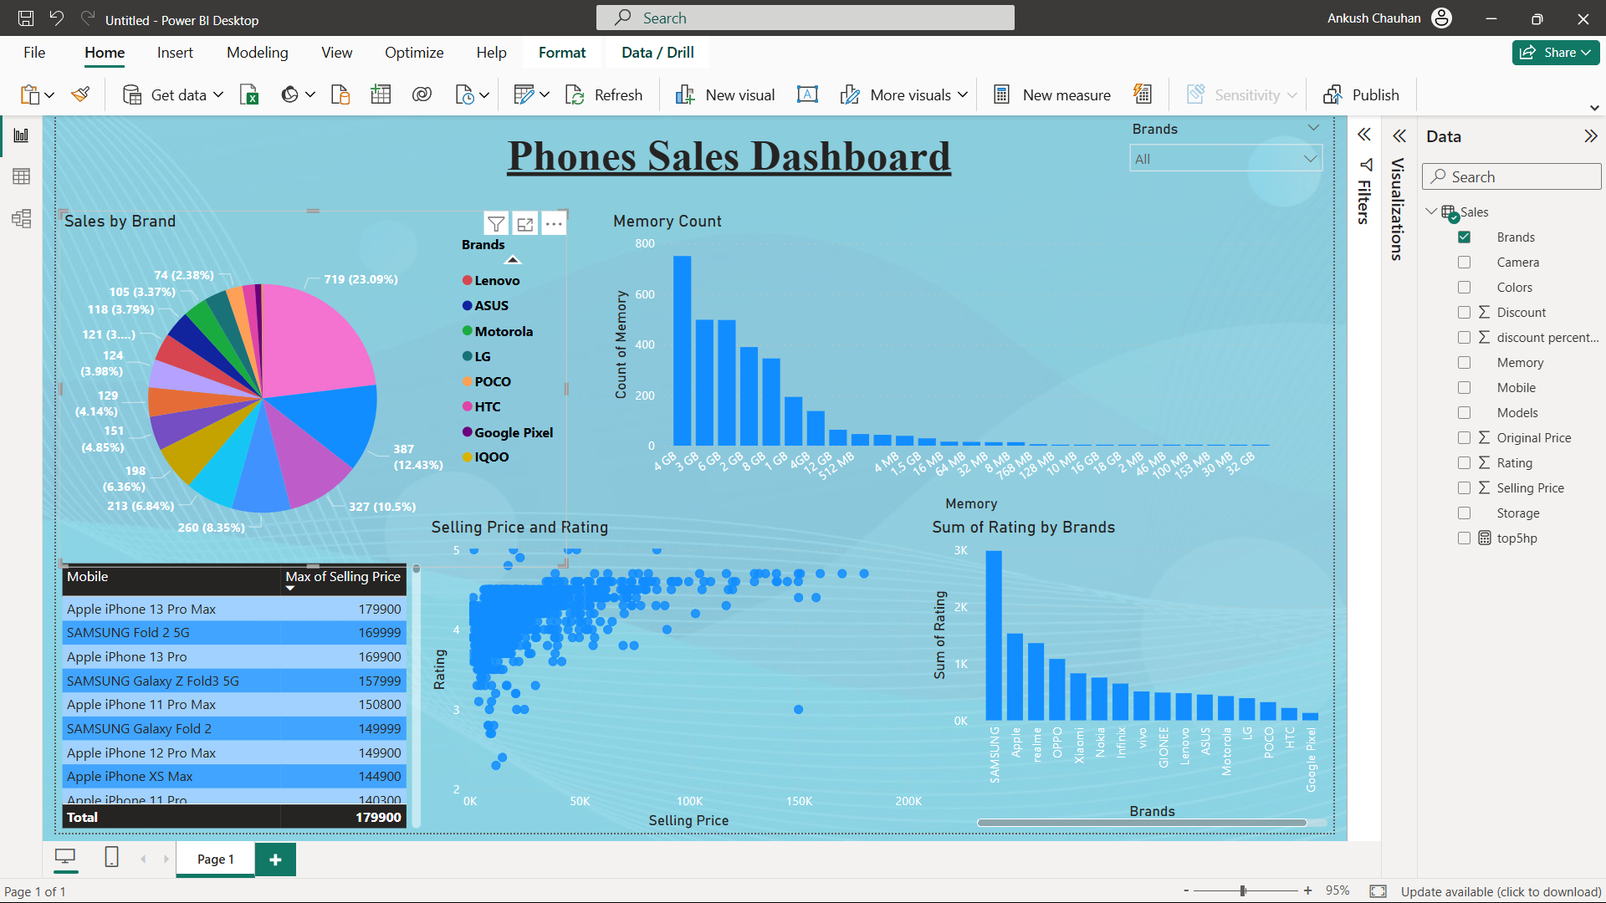

The pie chart clearly highlights **Lenovo** as the market leader, capturing **23.09%** of total phone sales.

Other significant contributors include **Samsung (12.43%)**, **Apple (10.5%)**, and **Xiaomi (8.35%)**.

This distribution shows that the market is highly competitive but slightly dominated by a few key players.

The bar chart illustrates the most popular memory configurations.

**4GB RAM** models dominate the sales, followed by **6GB** and **8GB**.

Lower memory models are still in circulation but are significantly less popular, indicating a shift in customer preference toward higher-memory smartphones.

The scatter plot shows the relationship between **Selling Price** and **Customer Ratings**.

Premium smartphones (priced above ₹100,000) generally maintain high ratings, confirming strong customer satisfaction despite higher costs.

Budget-friendly models have a wider spread in ratings, which may reflect variability in quality and user expectations.

**Samsung** leads in total customer ratings, indicating both high sales volume and consistent customer feedback.

**Apple** and **OPPO** also show strong customer engagement through ratings, reinforcing their competitive market positions.

Lesser-rated brands such as **HTC** and **Google Pixel** suggest either a lower sales count or limited market presence.

Focus on stocking higher-memory models, especially **4GB, 6GB, and 8GB**.

**Interview Question**

1. What is the importance of data visualization?  
 Data visualization is crucial because it transforms raw data into visual formats like charts, graphs, and maps, making complex information easier to understand and interpret. It helps uncover patterns, trends, and insights that may not be obvious in tables of numbers, enabling faster and more effective decision-making.

2. When do you use a pie chart vs. bar chart?  
 A pie chart is best when you want to show proportions or percentages of a whole — especially if you have limited categories (usually less than 5-6) and the focus is on the part-to-whole relationship.  
 A bar chart is better when you want to compare quantities across categories, especially when the categories are not parts of a whole or when you have more than a few categories. Bar charts are also easier to read when comparing differences in size.

3. How do you make visualizations more engaging?

* Use clear and relevant titles and labels.
* Choose the right chart type for the data and the story you want to tell.
* Use color thoughtfully — not just for aesthetics but to guide attention or group related elements.
* Add interactive elements (filters, tooltips, drill-downs) when possible.
* Simplify the design — avoid clutter, highlight key insights.

4. What is data storytelling?  
 Data storytelling combines data, visuals, and narrative to communicate insights clearly and persuasively. It’s not just about displaying numbers but guiding your audience through the “why” and “so what” behind the data. A strong data story has context, insight, and action.

5. How do you avoid misleading visualizations?

* Start charts at zero (especially bar charts) to maintain proportion integrity.
* Use consistent scales and avoid distorting axes.
* Label everything clearly — units, sources, categories.
* Avoid cherry-picking data ranges that exaggerate trends.
* Be transparent about limitations and context of the data.

6. What are best practices in dashboard design?

* Keep it simple: avoid overcrowding and prioritize clarity.
* Organize layout logically: top-to-bottom or left-to-right, placing the most important metrics first.
* Use consistent color schemes and fonts.
* Allow for interactivity like filters and drill-downs.
* Provide clear context: titles, date ranges, legends.
* Make it responsive for different devices if necessary.

7. What tools have you used for visualization?  
 You could mention tools based on your experience, for example:

* Tableau and Power BI for dashboards and business reporting.
* Matplotlib, Seaborn, Plotly for Python-based visualizations.
* Excel for quick exploratory analysis.